**Written Homework No. 3**

**Minimax and Expectimax  
  
Posted: Thursday 16th March 2017  
Submission Deadline: Thursday 23rd March 2017 @ 11:59 PM**

### Minimax Search and Pruning [20 Points]

Consider the zero-sum game tree shown below. Trapezoids that point up, such as at the root, represent choices for the player seeking to maximize; trapezoids that point down represent choices for the minimizer.

1. Assuming both opponents act optimally, carry out the minimax search algorithm. Write the value of each node inside the corresponding trapezoid and highlight the action the maximizer would take in the tree.

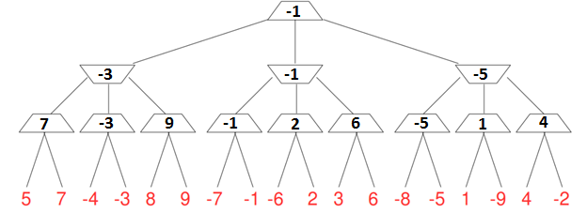Figure 1: Minimax tree for question a).

1. Now reconsider the same game tree, but use α-β pruning (the tree is shown in Figure 2). Expand successors from left to right. In the brackets ***[ , ]***, record the ***[α, β]*** pair that is passed down that edge (through a call to MIN-VALUE or MAX-VALUE). In the parentheses **( )**, record the value ***(v)*** that is passed up the edge (the value returned by MIN-VALUE or MAX-VALUE). Circle all leaf nodes that are visited. Put an ‘***X***’ through edges that are pruned off.

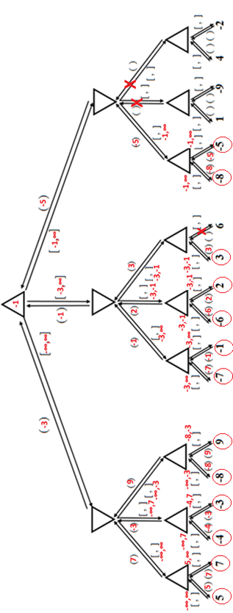

Figure 2: Minimax tree for question b).

1. Minimax and α-β pruning are guaranteed to find the same value of the top node [**True**/**False**]. **True**
2. Consider again the same game tree, searched using α-β pruning. This time, rather than expanding successors from left to right assume you can decide the order in which you expand successors. Find the order that results in exploring as few nodes as possible for this particular game. As in part (b), record the [α, β] values passed down the tree, and the (v) return values passed up. Circle all leaf nodes that are visited. Put an ‘**X**’ through edges that are pruned off.

**Solution at next page**

1. Assume you have an evaluation function which for each node can provide an estimate of the minimax value (though the estimate will not be perfect). How can you use these minimax value estimates to guide the order in which successors are expanded, with the goal of minimizing the number of leaf nodes visited while running the α-β pruning algorithm?

**Expand the maximum estimate for the maximizer and the minimum estimate for the minimizer. Only one will be expanded as a successor while the others will be pruned.**

d)   
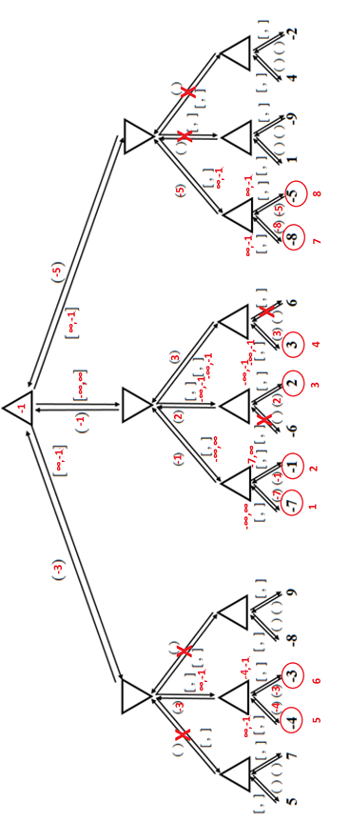

### 

### Expectimax for AI-Blackjack [30 Points]

Blackjack is the most widely played betting game in the world. The goal of the game is to be dealt a hand whose value is as close to **21** as possible without exceeding it. If the current value of a player’s hand is less than **21**, the player can “**hit**”, or be dealt a single card, in hopes of acquiring a hand with higher value. However, the player runs the risk of “busting”, or going over **21**, which results in an immediate loss. In this game play, players bet independently against a dealer, who plays according to a fixed set of rules that govern when he should **hit** or **stay**. In order to win cookies in an easy way, we consider a simplified variant called **AI-Blackjack**.

* There are only 3 cards in the deck: 5’s, 10’s and 11’s. Each card appears with equal probability.
* The cookie shop has invented an infinite deck. The probability of being dealt any given card is independent of the cards already dealt.
* To model the action of a dealer, we assume the cookie shop gives fixed payoffs according to the following schedule (in cookies!):

|  |  |
| --- | --- |
| Hand Value | Payoff |
| 0-14 | 0 |
| 15 | 3 |
| 16 | 3 |
| 17 | 3 |
| 18 | 3 |
| 19 | 3 |
| 20 | 9 |
| 21 | 12 |
| Bust | -6 |

* There are two actions available: **Hit**, which draws a card uniformly at random and adds its value to your current score, and **Stay**, which ends the game and yields the above payoff. If your score goes above **21** the game ends immediately with a payoff of **-6**. It is not possible to hit on **21**. Thus if you ever arrive at a hand value of **≥ 21**, there are no actions possible.

You are playing a hand of AI-Blackjack. You have been dealt 1 card, and its value is **11**.

1. Build the expectimax tree for this game, starting from your current hand and including all chance and max nodes. In your tree, you should put “**hit**” actions to the left of “**stay**” actions, and you should order max nodes below the same chance node in increasing order of the hand’s value (from left to right). Write the value of each state next to the given node. What is your optimal strategy? Specify your actions at all max nodes in the tree.

### 

Figure 3: Expectimax tree for AI-Blackjack (**p** denotes probability).

1. Unfortunately, you are playing with an **unscrupulous dealer** who is rigging the deck. Every time he deals a card, instead of dealing you a random card, he gives you the worst possible card you could get at that moment. What is the value of the game now and what is **your optimal strategy**?
2. When you complain about the cheating dealer to the cookie shop boss, a new dealer is brought in. This dealer is extremely nice: half of the time, when his boss is watching, he deals you a random card. The other half of the time, he deals you the best possible card you could get at that moment. Draw out the game tree for this (using the same instructions as (a)). What is the value of the game now and what is your optimal strategy?
3. The cookie shop owner, anxious about dwindling interest in **AI-Blackjack**, asks you to help him rework the game. He would like to increase the payouts for a value of **21** to **X** cookies. What is the minimal value of **X** cookies so that the optimal strategy for a player holding **16** changes? Assume fair dealers (as was assumed in part (a)).